Given an array **A[]** consisting of only **0s**, **1s,** and **2s**. The task is to write a function that sorts the given array. The functions should put all 0s first, then all 1s and all 2s in last.

This problem is also the same as the famous **“Dutch National Flag problem”**. The problem was proposed by Edsger Dijkstra. The problem is as follows:

*balls and then the blue coloured balls).*

**Examples:**

*, 1, 0, 1, 2, 1, 2, 0, 0*ission count: 5.4L

**Sort an array of 0s, 1s, and 2s using the Pointer Approach:**

This approach is based on the following idea:

* *The problem is similar to*[*“Segregate 0s and 1s in an array”*](https://www.geeksforgeeks.org/segregate-0s-and-1s-in-an-array-by-traversing-array-once/)*, if the element is 1 then keep it as it is.*
* *If the element is 2 then swap it with an element in high range.*

**Illustration:**

***arr[] = {0, 1, 2, 0, 1, 2}***

***lo****= 0,****mid****= 0,****hi****= 5*

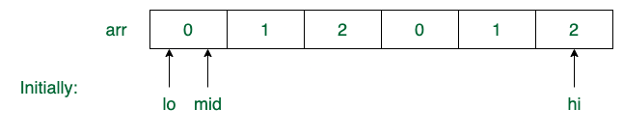

* *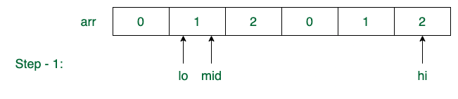d = mid + 1 = 1*
* 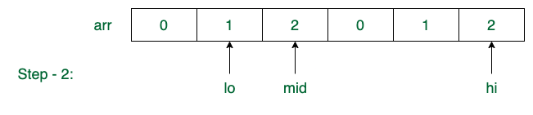

***Step – 2:****arr[mid] =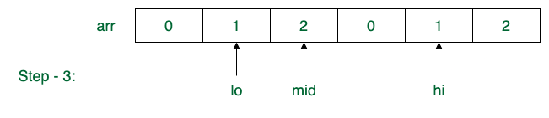= 1*

* *mid = mid + 1 = 2*
* *arr[] = {0, 1, 2, 0, 1, 2}*

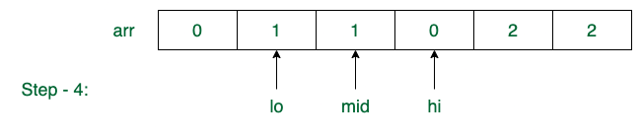

***Step – 3:****arr[mid] == 2*

* *swap(arr[mid], arr[hi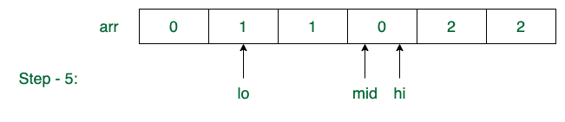])*
* *hi = hi – 1 = 4*
* *arr[] = {0, 1, 2, 0, 1, 2}*

***Step – 4:****arr[mid] == 2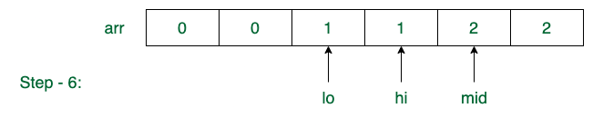*

* *swap(arr[mid], arr[hi])*

***{0, 0, 1, 1, 2, 2}***

Follow the steps below to solve the given problem:

* Keep three indices low = 1, mid = 1, and high = N and there are four ranges, 1 to low (the range containing 0), low to mid (the range containing 1), mid to high (the range containing unknown elements) and high to N (the range containing 2).
* Traverse the array from start to end and mid is less than high. (Loop counter is i)
* If the element is 0 then swap the element with the element at index low and update low = low + 1 and mid = mid + 1
* If the element is 1 then update mid = mid + 1
* If the element is 2 then swap the element with the element at index high and update high = high – 1 and update i = i – 1. As the swapped element is not processed
* Print the array.